**Department of IT & CS**

**Course Instructor: Rizwan Ali Lab Engr.: Usama Dated: 10/11/2023**

**Semester: Fall 2023**

**COMP-201L**

**Lab 04: Selection Sort & Bubble Sort**

|  |  |  |  |  |  |
| --- | --- | --- | --- | --- | --- |
|  |  | **CLO1** | **CLO2** | **CLO3** |  |
| **Name** | **Reg. No.** | **Lab Tasks Marks**  **20** | **Report**  **Marks**  **5** | **Viva**  **Marks**  **5** | **Total**  **Marks**  **30** |
| **Abuzar Khan** | **B22F1053SE023** |  |  |  |  |
|  |  |  |  |  |  |

**Lab Tasks:**

**Task 1: Write a code to sort the following arrays using bubble sort method.**

**[10, 34, 2, 56, 7, 67, 88, 42]**

**Task 2: Write a code to sort the following arrays using selection sort method.**

**[10, 34, 2, 56,7,67, 88, 42]**

**-: Bubble Sort: -**

**Program For Task 01:**

#include<iostream>

#define MAX 8

using namespace std;

int list[MAX] = {10, 34, 2, 56, 7, 67, 88, 42};

void display()

{

    int i;

    cout<<"[";

    for(i =0; i < MAX; i++)

    {

        cout<<list[i]<<" ";

    }

    cout<<"]\n";

}

void bubbleSort()

{

    int temp; int i,j; bool swapped = false;

    for(i = 0; i < MAX-1; i++)

    {

        swapped = false;

    for(j = 0; j < MAX-1-i; j++)

    {

        cout<<"Items compared: ["<<list[j]<<","<<list[j+1]<<"]";

    if(list[j] > list[j+1])

    {

temp = list[j];

list[j] = list[j+1];

list[j+1] = temp;

 swapped = true;

cout<<"=>swapped["<<list[j]<<","<<list[j+1]<<"]\n";

}

    else

    {

    cout<<" => not swapped\n";

    }

    }

    if(!swapped)

    {

    break;

    }

    cout<<"Iteration "<<i+1<<" #";

    display();

    }

}

int main()

{

    cout<<"Input Array: ";

    display();

    cout<<"\n";

    bubbleSort();

    cout<<"\nOutput Array: ";

    display();

    return 0;

}

**Output:**

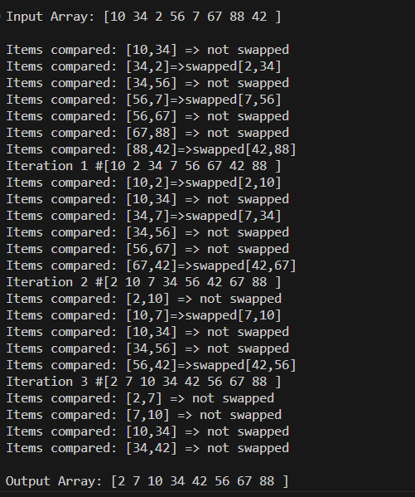

**-: Selection Sort: -**

**Program For Task 02:**

#include <iostream>

using namespace std;

#define MAX 8

int intArray[MAX] = {10, 34, 2, 56, 7, 67, 88, 42};

void printline(int count)

    {

        int i;

        for(i = 0;i < count-1;i++)

        {

            cout<<"=";

        }

        cout<<"=\n";

}

void display()

{

    int i;

    cout<<"[ ";

    for(i = 0;i < MAX;i++)

    {

        cout<< intArray[i]<<" ";

    }

    cout<<"]\n";

}

void selectionSort()

{

    int indexMin,i,j;

    for(i = 0; i < MAX-1; i++)

    {

        indexMin = i;

        for(j = i+1;j < MAX;j++)

        {

            if(intArray[j] < intArray[indexMin])

            {

                indexMin = j;

            }

        }

        if(indexMin != i)

        {

            cout<<"Items swapped: ["<<intArray[i]<<","<<intArray[indexMin]<<" ]\n";

            int temp = intArray[indexMin];

            intArray[indexMin] = intArray[i];

            intArray[i] = temp;

        }

        cout<<"Iteration "<<i+1<<" #:";

        display();

    }

}

int main()

{

    cout<<"Input Array: ";

    display();

    printline(50);

    selectionSort();

    cout<<"Output Array: ";

    display();

    printline(50);

    return 0;

}

**Output:**

